**PRACTICAL NO - 04**

**Create an AKS Cluster with Azure CLI**

### Step I – Install Azure CLI

* Go to <https://docs.microsoft.com/en-us/cli/azure/install-azure-cli?view=azure-cli-latest> ➤ Click on Install on Windows

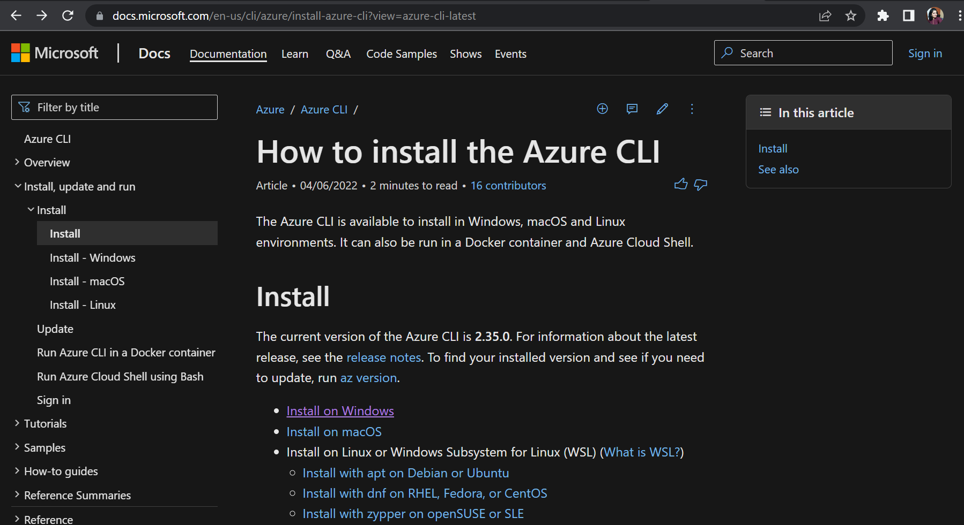

* You will navigate Install Azure CLI on Windows page. Scroll down ➤ Click on Latest version of the Azure CLI

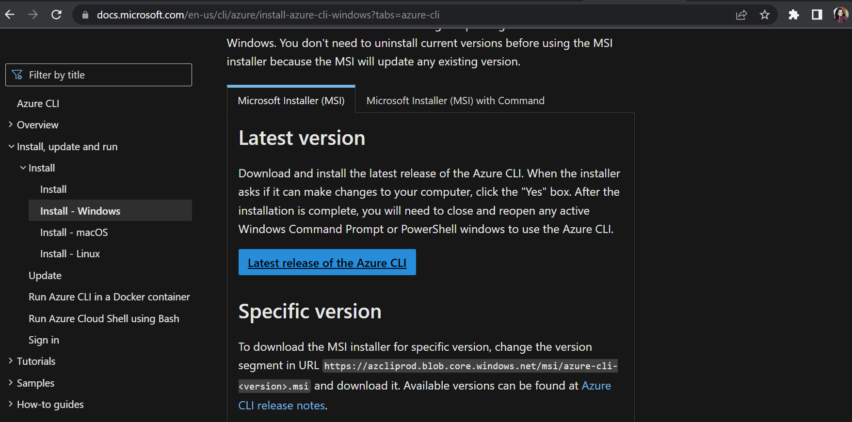

* It will download ***‘azure-cli-2.35.0.msi’*** file. Double click and Run it.
* The Microsoft Azure CLI Setup window will appear. Accept the License Agreement and click on ***Install.***

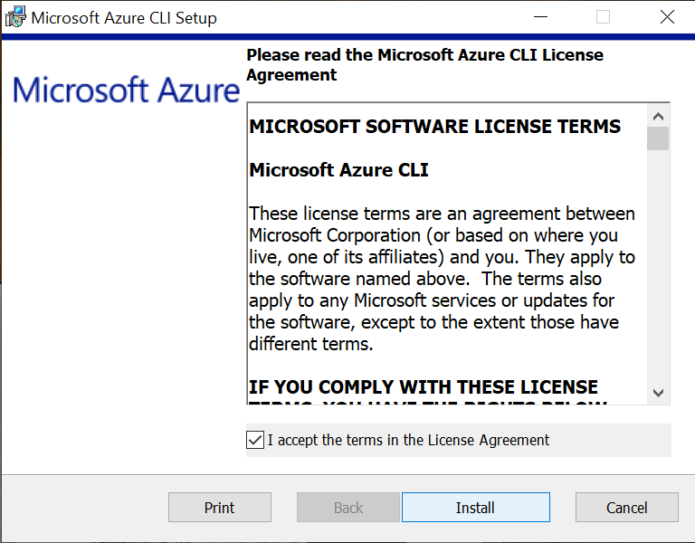

* The Azure CLI installation process will begin. Wait for a few minutes to complete the installation.

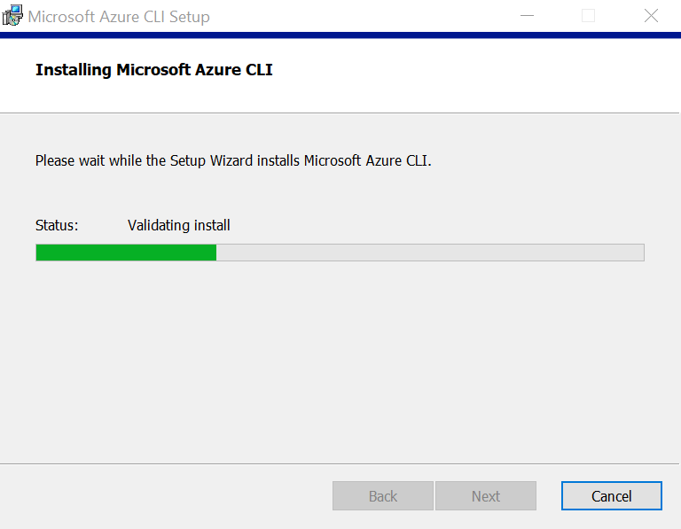

* Finally click on the Finish button.

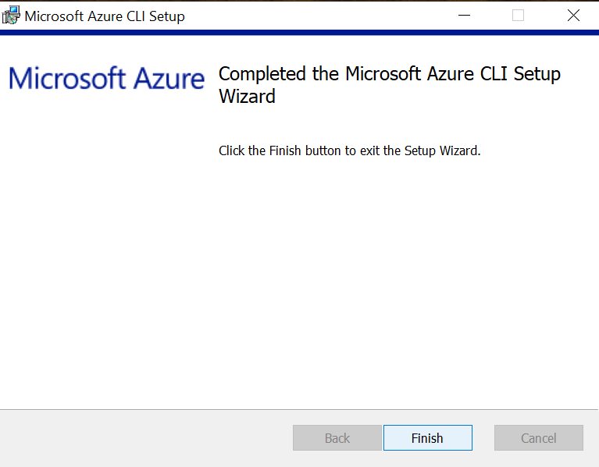

### Step II – Login to your Azure account.

* Open command prompt as an administrator.
* Sign in to the Azure CLI by using the ***az login*** command. To finish the authentication process, follow the steps displayed in your terminal.

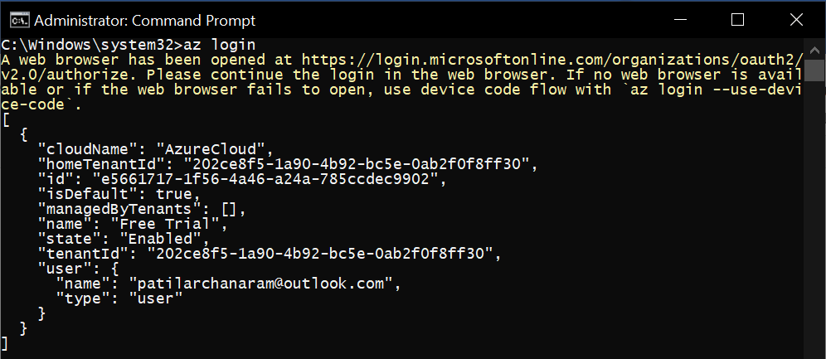

* Run ***az version*** command to find the version and dependent libraries that are installed.

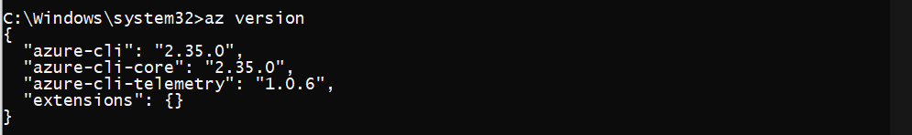

* To upgrade to the latest version, run ***az upgrade*** command.

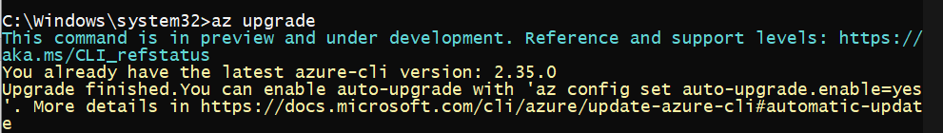

### Step III – Create a Resource Group.

* An Azure resource group is a logical group in which Azure resources are deployed and managed.
* When you create a resource group, you are asked to specify a location. This location is where resource group metadata is stored, it is also where your resources run in Azure. If you don't want to specify another region during resource creation, create a resource group using the ***az group create*** command.

***az group create --name myResourceGroup --location EastAsia***

OR

***az group create -n myResourceGroup -l EastAsia***

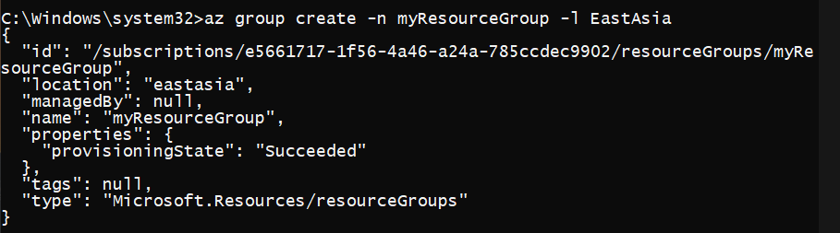

### Step III – Create AKS Cluster.

* Use the ***az aks create*** command to create an AKS cluster. The following example creates a cluster named myAKSCluster with one node. This will take several minutes to complete.

***az aks create --resource-group myResourceGroup --name myAKSCluster --node-count 1 --enable-addons monitoring --generate-ssh-keys***

OR

***az aks create -g myResourceGroup -n myAKSCluster -c 1 --generate-ssh-keys***

* After a few minutes, the command completes and returns JSON-formatted information about the cluster.

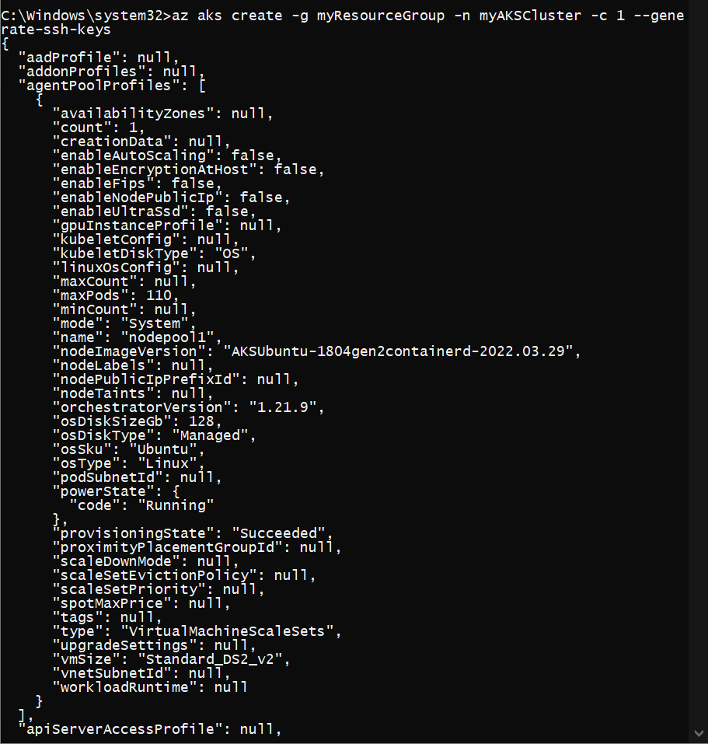

### Step IV - Connect to the cluster

* Configure ***kubectl*** to connect to your Kubernetes cluster using the ***az aks get-credentials*** command. The following command downloads credentials and configures the Kubernetes CLI to use them.

***az aks get-credentials -g [Resource Group] -n [Name of Azure Kubernetes Service]***



* Verify the connection to your cluster using ***kubectl ge***t to return a list of the cluster nodes.

***kubectl get nodes***

